

**Digital Image Processing Project Report**

**(SWE1010)**

**Title: Fake Currency Recognition System**

**Team member:**

**RITHIK V - 19MIS1189**

**Pondugala PRAVEEN – 20MIS1042**

**Kola Praneeth – 20MIS1151**

**Sudansh Rohan – 20MIS1163**

**Index**

1. Abstract
2. Motivation
3. Requirements
4. Modules
5. Objectives
6. Methodology
7. Architecture Diagram
8. Modules in detailed way
9. Results
10. Conclusion
11. References

**Abstract:**

Currency Recognition System distinguishes the between the fake and original currency notes of India. Our present framework is taking a shot at image processing, methods that incorporate image filtering, edge identification, segmentation and a database for putting away the qualities of the currency note.

* The main objective of this project is fake currency detection using the image processing. Fake currency detection is a process of finding the forgery currency. After choose the image apply pre-processing.
* In pre-processing the image to be crop, smooth and adjust. Convert the image into grey colour. After conversion apply the image segmentation. The features are extracting and reduce.
* Finally compare the image into original or forgery.

**Motivation:**

It is puzzling for individuals to perceive whether the currency notes are fake or original. Furthermore, some people may be misguide and use the fake currency notes in the market which makes many troubles to the people and the government. To determine this sort of issue we have a Currency Recognition System.

**Requirements:**

* Software Requirements:

- Programming Language: MATLAB

- Tool: MATLAB

- Operating System: Windows

* Hardware Requirements:

- A computer with all the basic features (Eg: Monitor, Keyboard, Mouse, Disk Space of 1GB, RAM of 2GB)

**Modules:**

* Image input
* Pre-Analysis
* Binary image of strip
* Minor closings
* Clean-up
* Grey Scale conversion

**Objectives:**

* The main objective of the project is to identify the fake currency notes automatically using Morphological Algorithm.
* Although there were many methods in existence, this method was designed to overcome the drawbacks of the previous methods. This method gives a faster and more accurate output when compared to the other techniques.
* This system also calculates the total currency that we have given input.

**Methodology:**

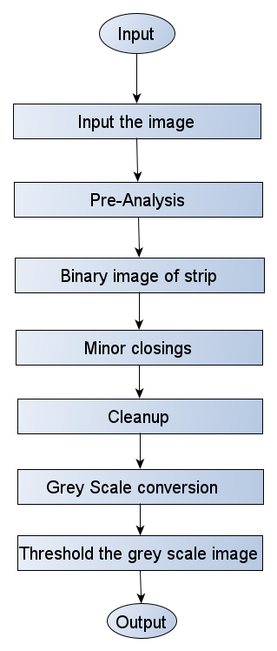

**Architecture Diagram:**

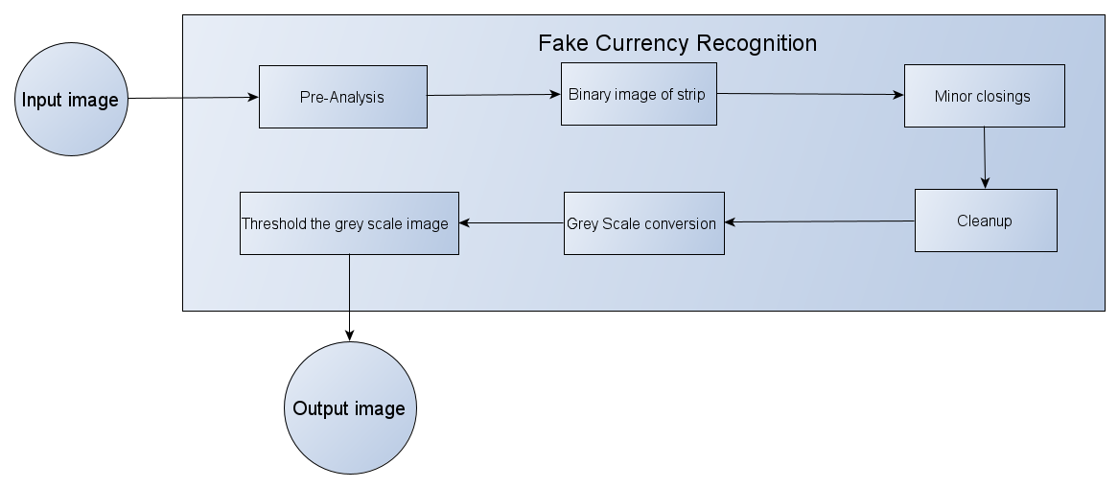

**Modules in detailed way:**

* Image input:

Input the real image and the scanned image.

* Pre-Analysis:

we will decompose image into HSV. The input image is which is in RGB is now converted to HSV image. Means both the real and scanned image will displayed in Hue, Saturation, and Value.

* Binary image of strip:

we will threshold the saturation and value planes so that we will get the combined saturation and the high and low values will become part of black strip. Now we will get a cropped image that will gives us black strip.

* Minor closings:

In the fake note the black lines are separated by few pixels but in the original image these is no such separation. While connecting the lines in both images lines in fake cannot be connected because they are very far a-part while it helps in our real-image analysis.

* Cleanup:

Since there are some noisy pixels on edges of the image, it removes the pixels that don’t belong to the strip.

* Grey Scale conversion:
* The input image is converted into RGB to GREY scale.
* Contrast enhances the grey image to emphasize dark lines in lighter background.
* Remove the dark line.
* Convert closed image to grey scale.
* Take the difference between the closed grey scale and enhanced grey scale to find the image projection.
* Smooth the projection
* Threshold the projection
* Get the number of segments
* **Thresholding and Smoothening of the image:**
* Thresholding is a technique where that creates the bitonal (aka binary) on setting a threshold value on the pixel intensity of the original image.
* Smoothening is used to reduce the noise and generate a less pixelated image using low-pass filters.
* We compare the intensity levels of both original and fake currency notes.
* **Extraction of Black Strips:**
* Every currency notes has some unique characteristic. Every currency has black strips in RGB. And it’s one of the unique characters of money.
* Now, we are converting the coloured strips into grey-scale for better understanding the black-stripes and by comparing them we can able to distinguish between a fake currency and original currency.
* **Outcome:**
* After extracting the black stripes, when the output of the image is ‘1’, then the image is original or else the image is fake.

**Results:**

1. **Indian 100 Rs note:**
   1. Pre-Analysis for original image:



* 1. Pre-Analysis for scanned image:



* 1. Binary image of strip:



* 1. Grey Scale conversion:

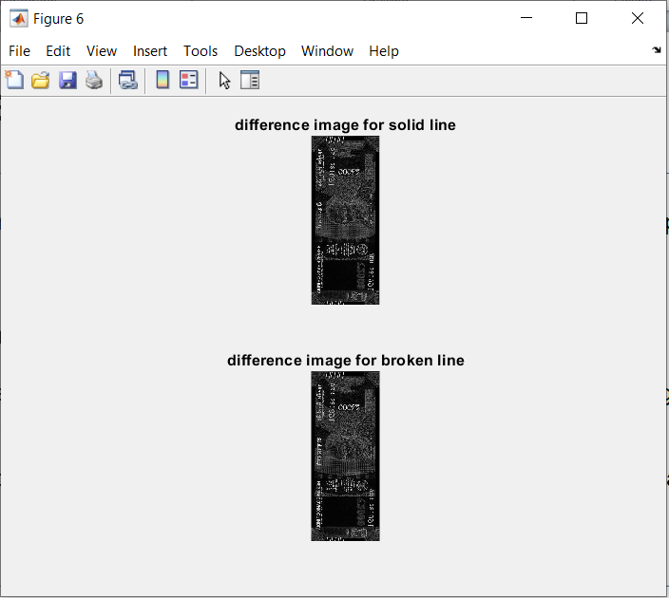

* 1. Thresholding and Smoothening of the image:

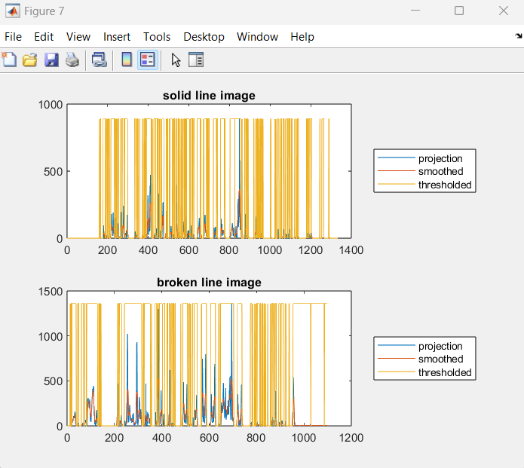

* 1. Extraction of Black Strips in RGB:



* 1. Extraction of Black Strips in Grey scale:



* 1. Output:

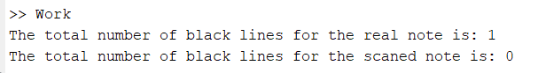

1. **Bangladesh 100 taka note:**
   1. Pre-Analysis for original image:

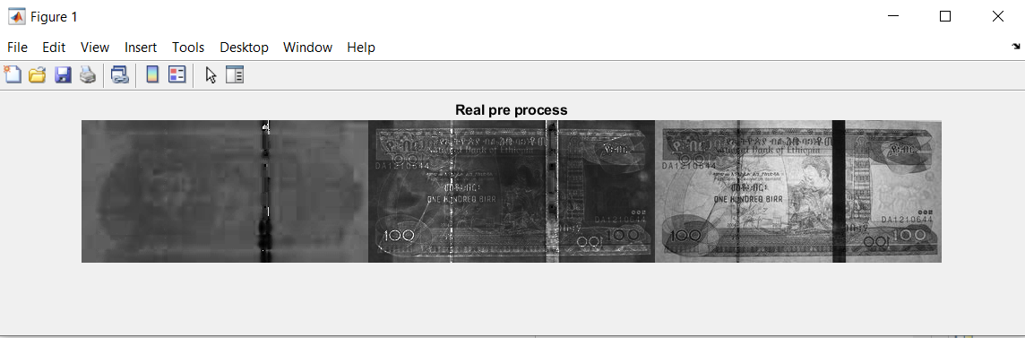

* 1. Pre-Analysis for scanned image:

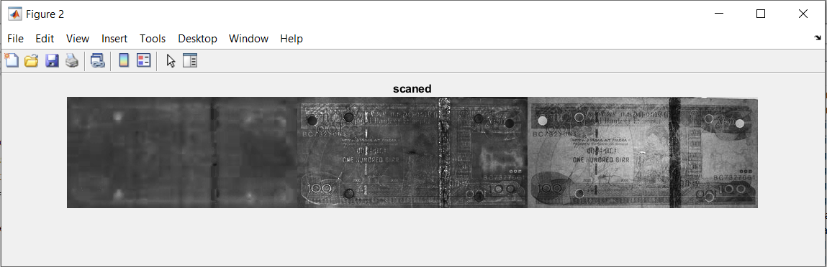

* 1. Binary image of strip:

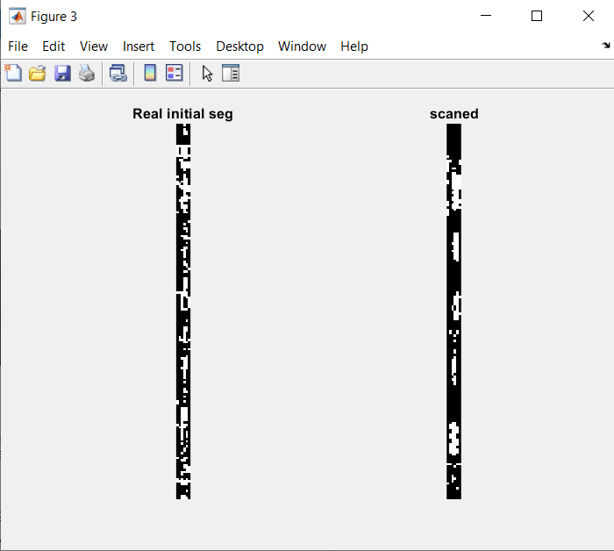

* 1. Minor closings:

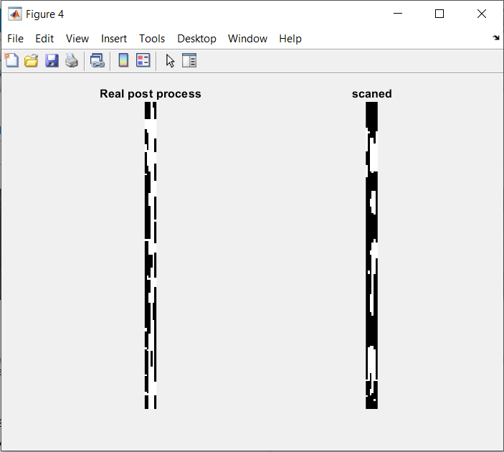

* 1. Clean-up:

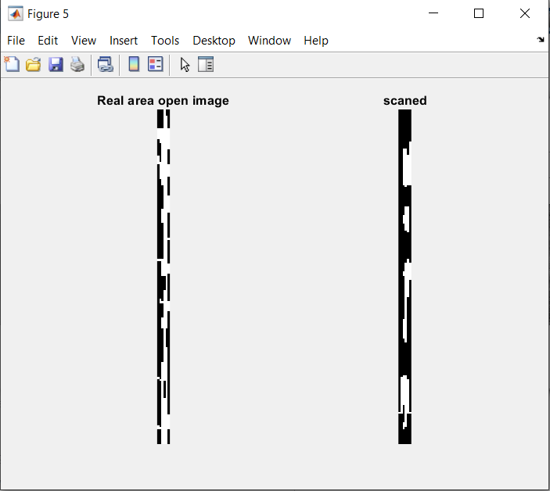

* 1. Grey Scale conversion:

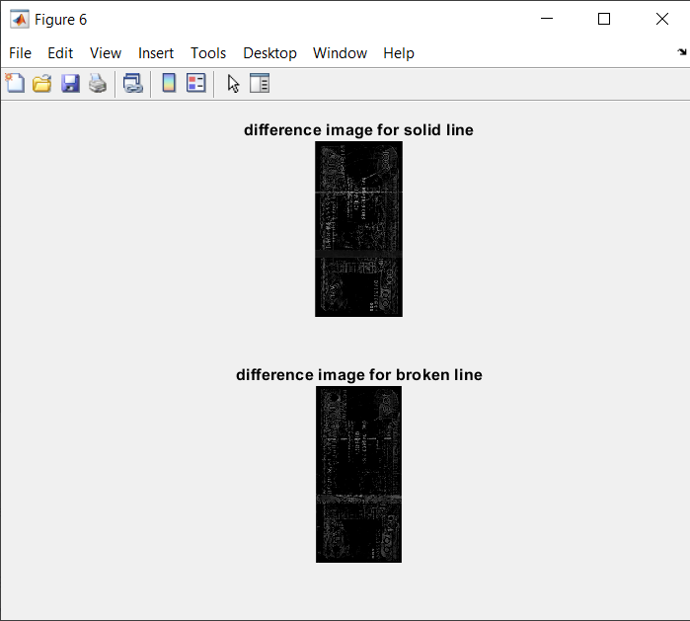

* 1. Thresholding and Smoothening of the image:

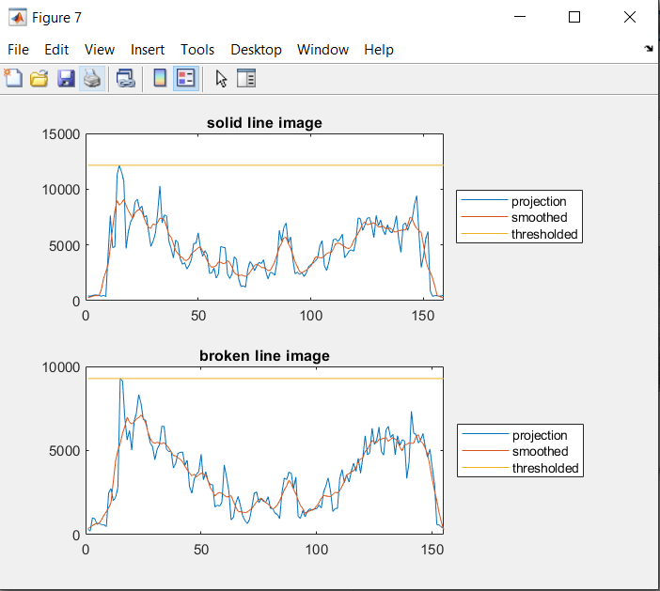

* 1. Extraction of Black Strips in RGB:

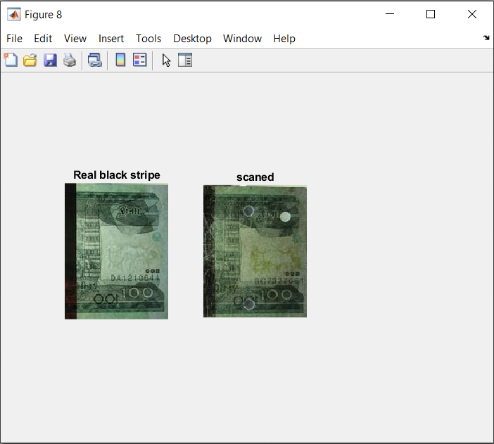

* 1. Extraction of Black Strips in Grey scale:

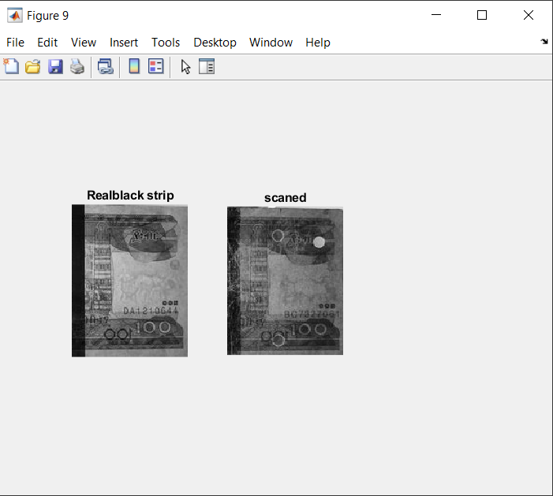

* 1. Output:

E:\Digital image processing\project\10.PNG

**Conclusion**

The currency is identified whether it is fake or original by using the image processing techniques and if the output is “1” for real image and else it is for fake image.

**References:**

* <https://www.researchgate.net/publication/323056402_Currency_recognition_system_using_image_processing>
* <https://www.slideshare.net/mobile/FatimaAkhtar6/currency-recognition-system-using-image-processing-79947602>
* A. S and D. M. Sasikumar, "Fake Currency Detection," 2019 International Conference on Recent Advances in Energy-efficient Computing and Communication (ICRAECC), 2019, pp. 1-4, doi: 10.1109/ICRAECC43874.2019.8994968.
* Ankush Singh , Ankur Pandey , Aman Tekriwal , Prashant Mankani, Prof. Ketaki Bhoyar, 2019, Detection of Fake Currency using Image Processing, INTERNATIONAL JOURNAL OF ENGINEERING RESEARCH & TECHNOLOGY (IJERT) Volume 08, Issue 12 (December 2019).
* Gouri Sanjay Tele et al.” Detection of Fake Indian Currency” in International Journal of Advance Research, Ideas and Innovations in Technology, Volume 4, Issue 2, 2018.